Building an Anticipatory Content Strategy: Integrating Audience Data, Behavioral Analytics, and Predictive Frameworks

Executive Summary
All three structural gaps — late-stage content risk identification, fragmented audience understanding, and reactive slate gap detection — stem from a single architectural deficiency: content strategy infrastructure designed for a world where data arrives after decisions are made. Closing these gaps requires a unified data architecture that merges viewing behavior with consumer identity, deploys AI-driven simulation to assess content before production, and surfaces underserved audience cohorts in real time.
The most consequential finding is that pre-launch content assessment is now technically feasible and commercially validated. AI “pseudo-viewers” trained on combined content and consumer signals can evaluate structural properties — onboarding risk, pacing alignment, recall potential — against historical retention curves, producing confidence-scored signals that complement editorial judgment without scoring creative quality [1]. External benchmarks reinforce this: Cinelytic claims up to 85% accuracy in pre-production forecasting [2], and synthetic audience research has compressed traditional focus-group timelines from weeks to hours [3, 4].
Equally critical, linking streaming behavioral data with consumer panel profiles across categories like travel, beauty, and electronics transforms audience personas from content development tools into commercial assets [1]. A show that tests well against a persona with strong advertiser-relevant affinities becomes a pre-sold revenue story at the concept stage — shifting the content-to-advertising relationship from sequential to simultaneous [1]. Disney’s Audience Graph [5] and Netflix’s integration of Amazon Audiences [6] confirm the industry is converging on this capability.
The Grow/Nourish/Sustain framework provides the operational mechanism for live gap detection, classifying personas by segment size and engagement depth so that every commissioned title maps to a strategic role and underserved cohorts are surfaced proactively rather than discovered through attrition [1]. Organizations that build this integrated architecture first will make content decisions earlier, with greater confidence, and with a direct line of sight to both audience value and advertiser value.

Introduction: The Case for Anticipatory Content Strategy
Content decisions in media and streaming have long relied on two inputs: the qualitative judgment of experienced executives and performance data that arrives after a show has launched. Both are valuable, but neither is sufficient to meet the demands of an increasingly competitive, data-rich environment. Three structural gaps define the current limitation. First, concepts and scripts are assessed without a consistent, data-grounded view of how the intended audience is likely to experience them, meaning that risks in onboarding, pacing, and retention are identified late — in pilots or post-launch — when the cost of correction is highest [1]. Second, audience understanding is fragmented: viewing behavior data and consumer profile data exist independently, producing a partial picture that describes how viewers watch but not who they are as consumers, and therefore cannot inform advertising strategy or identify the full commercial value of a given audience segment [1]. Third, there is no live mechanism for understanding which audience cohorts are underserved by the current slate, so content gaps and acquisition priorities are identified reactively rather than surfaced proactively by the data [1].
These are not marginal inefficiencies. They represent the difference between a content strategy that is reactive and one that is anticipatory. Closing these gaps requires a new architecture — one that unifies fragmented data, synthesizes actionable audience personas, and deploys those personas across three capabilities: pre-launch content assessment, commercial value identification, and live slate gap detection. This report examines the frameworks, technologies, and measurement systems that make such a shift possible, drawing on both an internal strategic proposal for an Audience Simulation Engine and external industry developments through early 2026.

Pre-Launch Content Assessment Through Audience Simulation
The most consequential content decisions — what to commission, what to acquire, what to renew — are made before audiences ever see the work. Yet the data infrastructure that supports those decisions has historically been backward-looking, relying on post-launch performance metrics to inform future choices. The emerging discipline of audience simulation aims to reverse this sequence.
AI Pseudo-Viewers and Structural Signal Detection. The Audience Simulation Engine proposal describes a framework in which AI “pseudo-viewers” are trained on combined content and consumer signals for specific audience segments, drawing on historical show performance data to evaluate incoming scripts, outlines, and episode structures [1]. Rather than scoring creative quality — dialogue, performance, casting, or production values — the system evaluates structural content properties against historical retention curves [1]. It surfaces three types of signal: engagement prediction, which identifies where in a content’s structure early-exit risk is elevated; narrative density read, which assesses whether pacing and structural movement align with the known behavioral patterns of the target audience; and social and recall signal, which evaluates whether the content contains the structural elements — dilemmas, memory anchors, compounding hooks — that drive word-of-mouth and return viewing [1]. All outputs are directional and confidence-scored, providing commissioning teams with a data-grounded layer of insight that complements rather than replaces creative judgment.
External Benchmarks in Script Analytics. The commercial market for pre-launch content evaluation is maturing rapidly. Cinelytic acquired Jumpcut Media in 2025, integrating Jumpcut’s ScriptSense tool to allow users to manage, analyze, and evaluate IP including film and television scripts and books at scale [7]. Cinelytic claims up to 85% accuracy in predictive forecasting before a film has been made [2], and in 2024 launched a proprietary Streaming Consumption Score to predict and track per-title digital content consumption across platforms and countries [8]. Meanwhile, The Times (UK) began using synthetic audience research in 2025, working with Electric Twin to create AI-generated simulations modeled on its subscriber panel, compressing traditional focus-group timelines from weeks to hours [3, 4]. These developments signal a broader industry shift toward treating audience response as something that can be modeled before production, not merely measured after it.
Microdrama as a Live Testing Ground. At the other end of the spectrum, microdrama platforms now function as real-time testing environments where performance signals arrive in real time and story arcs can be refined before larger capital commitments are made [9]. Platforms often know within days whether a series scales or stalls, and vertical releases may serve as proof of concept for remakes and spin-offs. This model offers a complementary pathway to simulation — one grounded in actual audience behavior at low cost and high speed.

Unified Audience Profiles: Merging Viewing Behavior with Consumer Identity
The second structural gap — fragmented audience understanding — cannot be solved by better analytics alone. It requires a new data architecture that links what viewers watch with who they are as consumers.
A Three-Layer Integration Architecture. The Audience Simulation Engine proposal describes a unified anonymized dataset that links streaming behavioral data (retention curves, drop-off patterns, genre affinity, session depth) with 16 consumer panels spanning categories such as travel, beauty, electronics, and fashion [1]. From this unified dataset, content-first clustering builds 5–6 synthesized personas across five dimensions: retention profile, content preference, viewing behavior, demographic overlay, and engagement depth [1]. Together, these personas account for approximately 75% of the active audience base. Each persona is then mapped against the 16 consumer panels to identify statistically significant, probabilistic affinities that are behavior-grounded, not assumed [1].
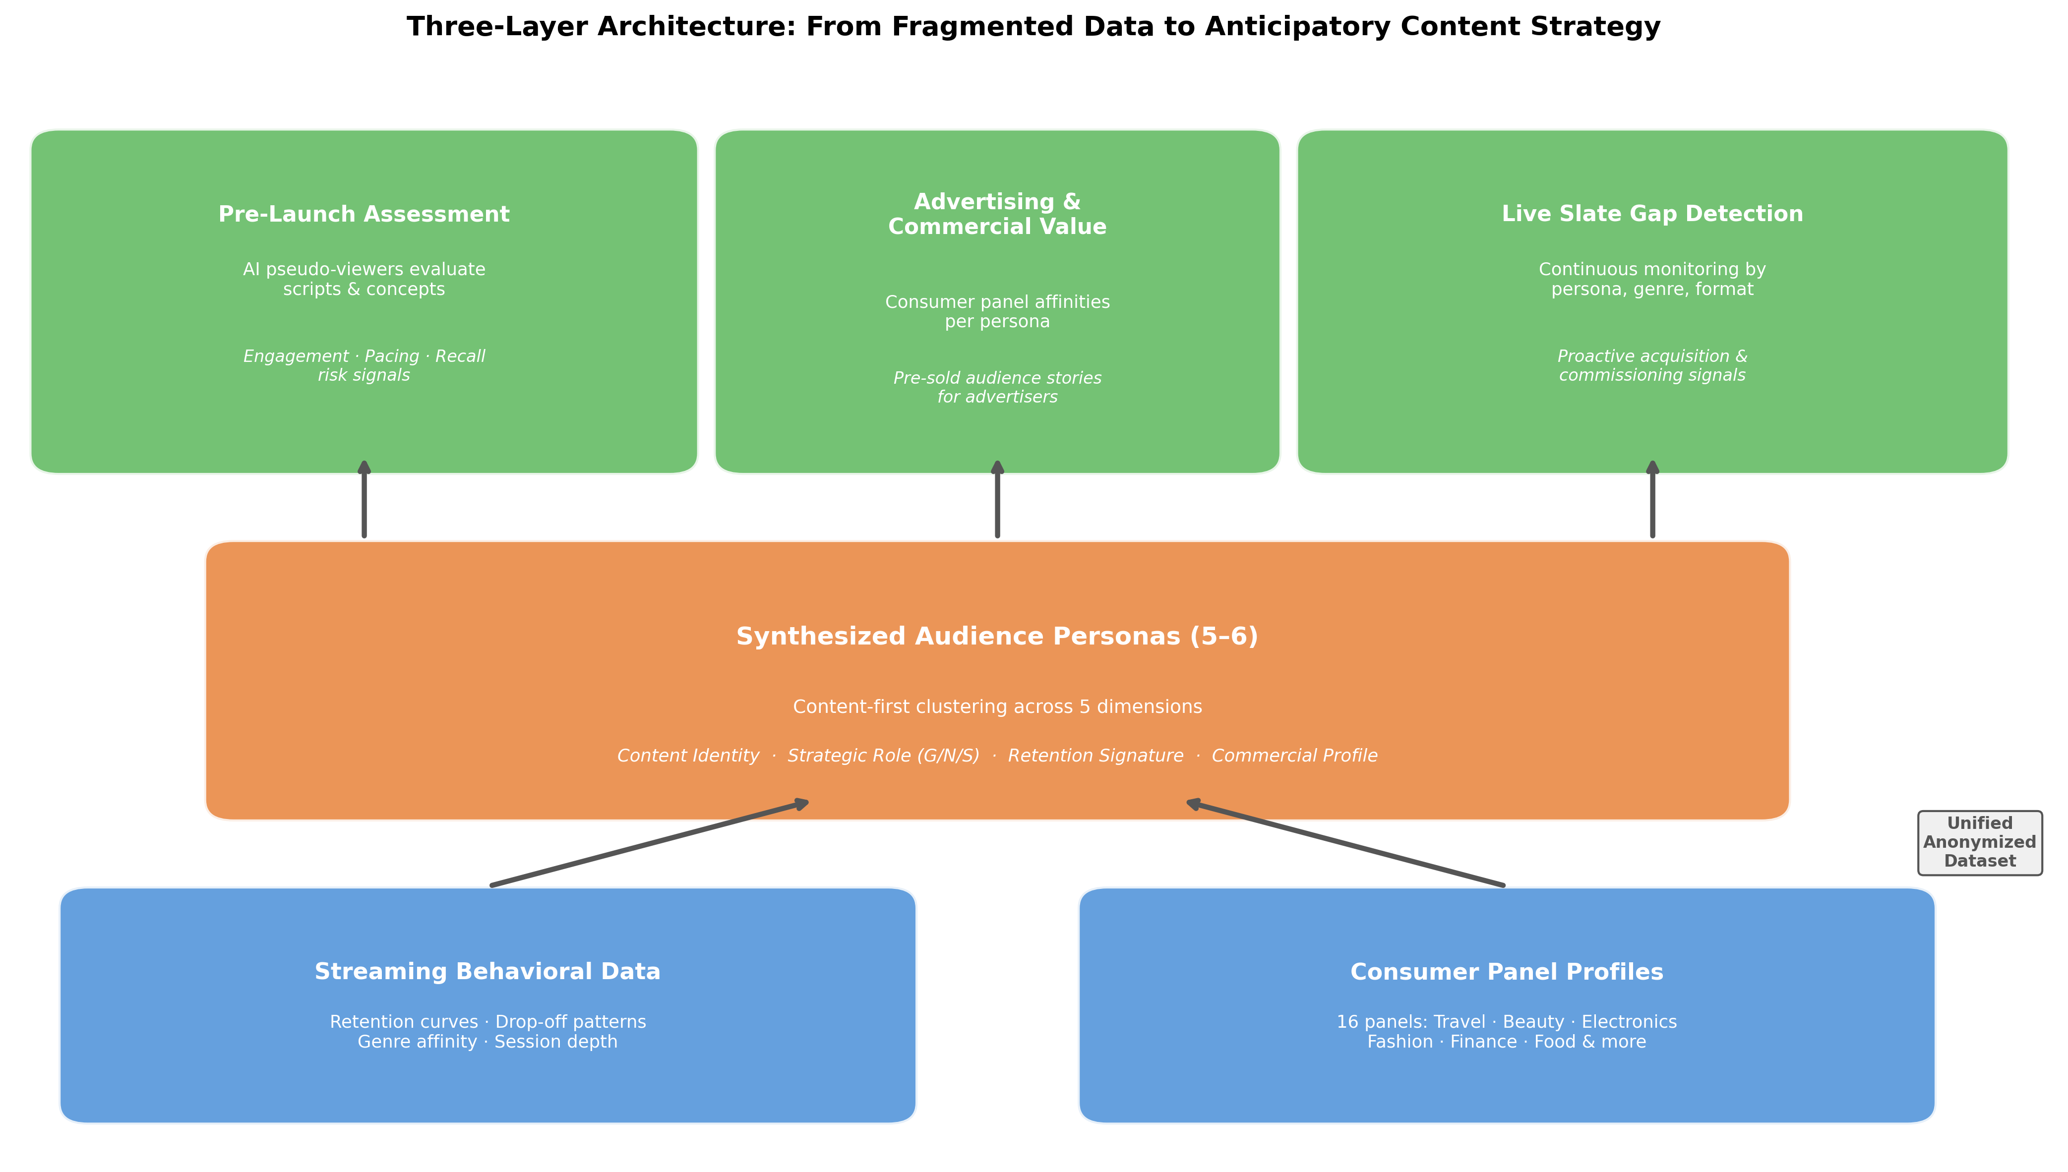
Three-Layer Architecture
Chart Explanation: This diagram illustrates how streaming behavioral data and consumer panel profiles merge into a unified anonymized dataset, which feeds content-first persona clustering. The resulting synthesized personas then power three strategic capabilities: pre-launch content assessment via AI pseudo-viewers [1], advertising and commercial value identification through consumer panel affinities [1], and live slate gap detection by persona, genre, and format [1].
Each synthesized persona carries four simultaneous properties: a content identity describing what and how they watch, a strategic role within the Grow/Nourish/Sustain framework, a retention signature providing behavioral baselines for onboarding, narrative density, and recall, and a commercial profile linking the persona to advertiser-relevant consumer categories [1].
Industry Parallels. Disney’s Audience Graph represents a functionally analogous approach at scale, ingesting consumption and demographic signals across all Disney endpoints into a proprietary graph built on Snowflake’s Data Cloud, delivering over 2,000 pre-built audience segments for advertiser targeting [5]. Netflix’s Ads Suite, launched in 2025 and expanded in 2026, integrates Amazon Audiences — built from trillions of shopping, streaming, and browsing signals — and Yahoo DSP deterministic audiences to enable behavioral and retail-informed targeting, with early Conversion API testing outperforming benchmarks by more than 75% [6]. The broader industry trajectory is clear: modern CDPs are shifting from passive data collection to AI-powered intelligent activation, requiring sophisticated identity resolution across web, mobile, and OTT platforms [10]. By 2027, privacy-enhancing technologies are expected to underpin half of programmatic advertising, with clean-room-led cooperatives and federated identity frameworks becoming strategic infrastructure [11].
Unlocking Commercial Value Before Commissioning. The critical advantage of unified profiles is that they connect content decisions to revenue outcomes before production investment is committed. A show that tests well against a persona with strong beauty and travel panel attachment is not just a content win — it is a pre-sold audience story for premium advertisers [1]. This capability transforms the relationship between content and advertising teams from sequential (content is made, then sold) to simultaneous (content is evaluated for both audience engagement and commercial value at the concept stage).

Live Content Gap Detection and Underserved Cohort Identification
The third structural gap — the absence of a live mechanism for surfacing underserved audience cohorts — is perhaps the most strategically consequential. Without it, content gaps become visible only after they have already cost the platform viewers.
The Grow / Nourish / Sustain Framework. The Audience Simulation Engine addresses this through a strategic framework that classifies each synthesized persona into one of three roles based on audience segment size and engagement depth [1]. GROW personas represent large audience segments with moderate engagement — the biggest conversion opportunity, requiring accessible, high-concept content with strong onboarding to convert casual viewers into habitual ones [1]. NOURISH personas are mid-size segments with consistent but not deep engagement, needing breadth within their preference zone to deepen investment. SUSTAIN personas are smaller, highly engaged segments representing the platform’s most loyal and commercially valuable audience, requiring depth and distinctiveness to maintain retention [1].
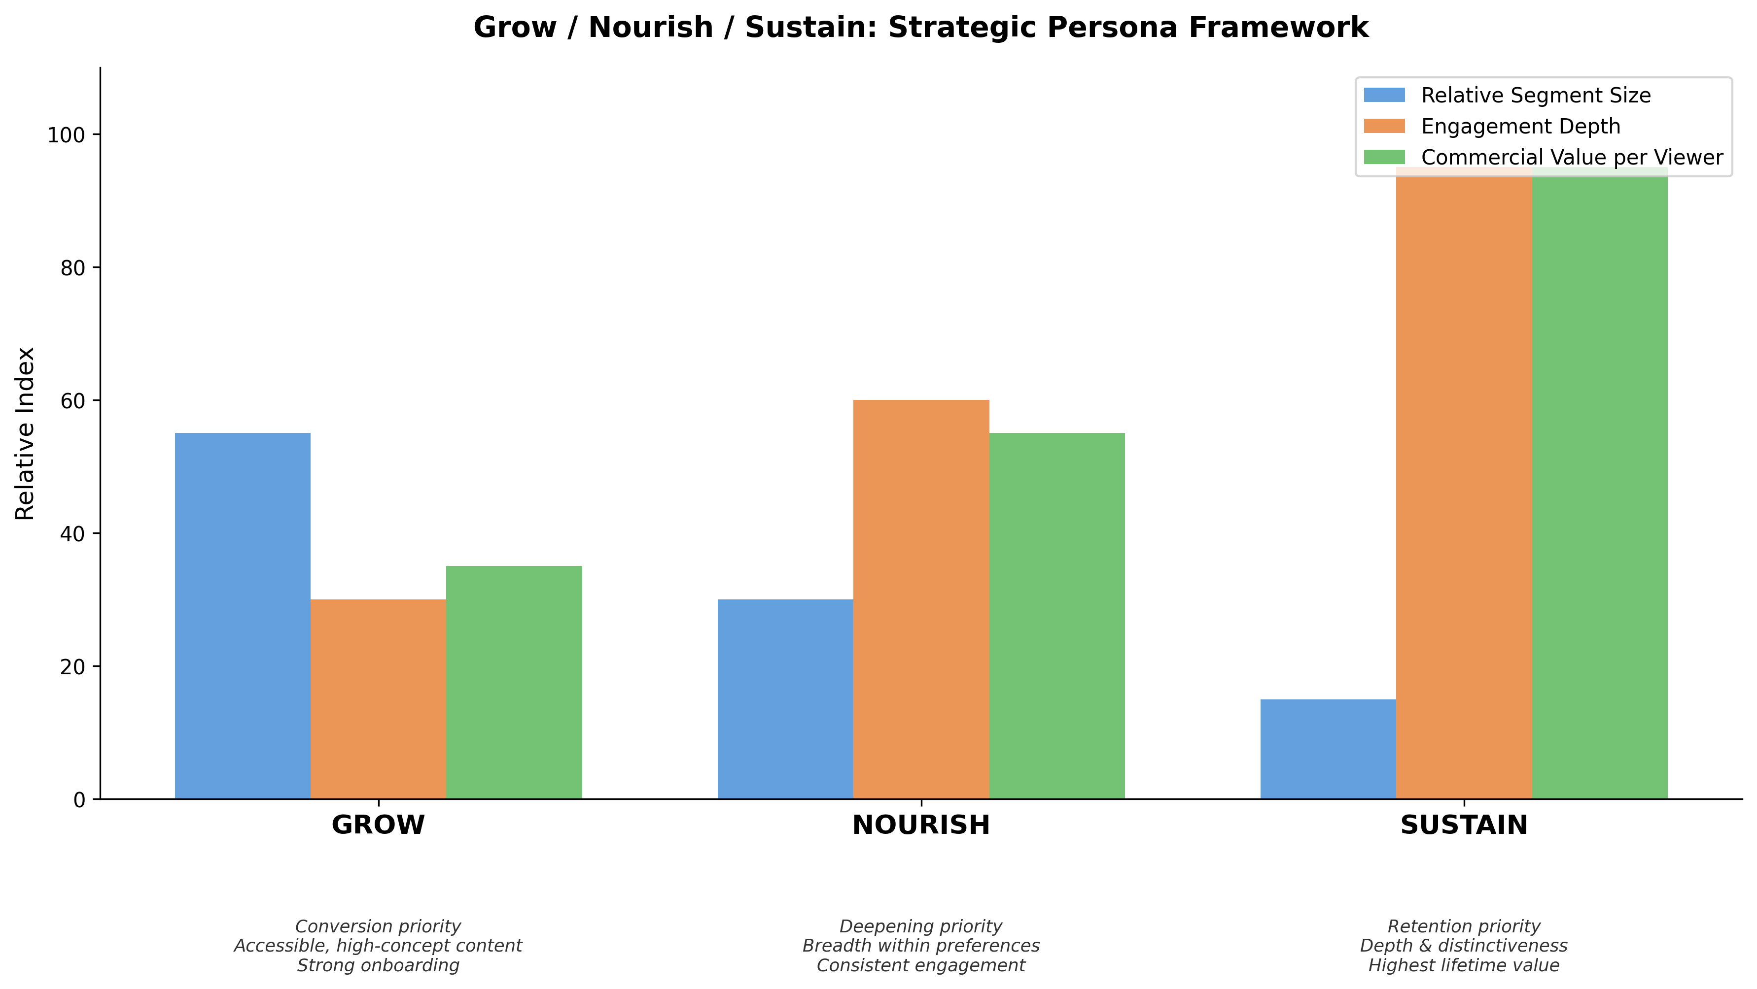
Grow / Nourish / Sustain Framework
Chart Explanation: This chart illustrates the inverse relationship between segment size and both engagement depth and per-viewer commercial value across the three strategic tiers. GROW segments are the largest but least deeply engaged, while SUSTAIN segments are the smallest but most commercially valuable per viewer [1]. Each tier carries distinct content investment priorities and KPIs.
This framework transforms the persona set from a content development tool into a commissioning and acquisition strategy. Every show can be mapped to the job it is doing for the service, and gaps in the slate become visible before they become visible in the data [1].
External Demand Sensing Systems. Parrot Analytics’ DEMAND360 platform provides a complementary external signal, offering real-time access to global audience demand data across more than 50 markets, updated daily, capturing billions of audience signals weighted by consumer effort [12]. Their content valuation system measures the dollar-value contribution of any title to any platform in any region [13]. In 2025, demand data exposed growing inefficiencies where genres like anime, action fantasy, and crime drama franchises consistently outperformed their supply, while other categories showed limited breakout potential [14]. Social sentiment monitoring offers another leading indicator: matching social media posts for sentiment to catalog tags enables real-time signals — such as trending content on TikTok — that turn social buzz into actionable programming intelligence [15].
Embedding Intelligence into Workflows. Netflix’s shift to a knowledge graph architecture signals that leading platforms are restructuring their data layers to be AI-native, enabling backend systems to provide real-time knowledge of what content to acquire and dispose of [16]. The structural advantage, however, lies not just in having the data but in how it reaches decision-makers. Services that embed real-time dashboards directly into programming and acquisition workflows — replacing the traditional analyst-report-present cycle — will have a structural advantage as licensing windows shorten and competitive catalogs shift daily [15].

Measurement Architecture: KPIs That Connect Content to Commercial Outcomes
An anticipatory content strategy requires a measurement framework that is equally forward-looking — one that connects content decisions to engagement depth, retention, and commercial outcomes rather than relying on vanity metrics or post-hoc analysis.
Tiered KPIs Aligned to Strategic Roles. The Grow/Nourish/Sustain framework provides a natural structure for tiered measurement. GROW personas are measured on conversion metrics — onboarding success and habit formation. NOURISH personas are measured on engagement breadth and deepening within existing preferences. SUSTAIN personas are measured on churn resistance and lifetime value [1]. This tiered approach ensures that content performance is evaluated against the strategic job it was commissioned to do, rather than against a single universal benchmark.
Content Scoring Without Creative Judgment. The AI pseudo-viewer simulation produces confidence-scored signals across three dimensions — engagement prediction, narrative density alignment, and social/recall potential — without scoring creative quality [1]. This distinction is critical: the system evaluates structural content properties against historical behavioral data, providing a data layer that complements editorial judgment rather than competing with it. The PREDICT framework (Pattern recognition, Risk scoring, Early intervention, Dedicated support, Individualized offers, Continuous optimization, Tracking ROI) is emerging as a complementary standard for analytics-driven churn prevention, integrating behavioral signals, sentiment analysis, and discovery patterns [17].
Cross-Platform Measurement Evolution. The measurement vendor landscape is diversifying rapidly. In 2025, the U.S. Joint Industry Committee certified Comscore, iSpot, and VideoAmp as transaction-ready alternatives to Nielsen for cross-platform audience measurement [18]. For ad-supported models specifically, key metrics now prioritize video completion rate (with benchmarks above 95% for CTV), viewable impressions, and average watch time as engagement-quality signals that connect content environments to ad effectiveness [19]. AI-driven segmentation further enhances monetization by enabling video service providers to identify highly granular audience segments, improving campaign performance and increasing CPM rates while unlocking new formats such as shoppable ads and event-driven interactive ads [20].
Capability | Key Metrics | Strategic Purpose
Pre-Launch Assessment | Engagement prediction score, narrative density alignment, social/recall signal [1] | Identify structural risk before production investment
Unified Audience Profiles | Consumer panel affinity strength, persona coverage (≈75% of active base) [1] | Connect content decisions to advertising revenue
Slate Gap Detection | Underserved persona count, demand-supply ratio by genre [12, 14] | Proactive commissioning and acquisition signals
GROW Tier | Onboarding conversion rate, habit formation [1] | Convert casual viewers to habitual ones
NOURISH Tier | Engagement breadth, preference-zone depth [1] | Deepen mid-tier viewer investment
SUSTAIN Tier | Churn resistance, lifetime value [1] | Retain highest-value audience segments
Table: Measurement Framework — KPIs Aligned to Strategic Capabilities

Conclusion: From Partial Picture to Integrated Intelligence
The three structural gaps identified at the outset — late-stage risk identification, fragmented audience understanding, and reactive gap detection — are not independent problems. They are symptoms of a single underlying condition: a content strategy architecture that was designed for a world where data arrived after decisions were made. The frameworks examined in this report describe a different architecture, one in which unified audience data feeds synthesized personas that simultaneously power pre-launch content assessment, commercial value identification, and live slate monitoring [1].
The internal Audience Simulation Engine proposal provides a coherent blueprint for this integration, while external developments — from Cinelytic’s script analytics [7, 2] to Disney’s Audience Graph [5], Netflix’s expanded Ads Suite [6], and Parrot Analytics’ demand sensing [12] — confirm that the industry is converging on similar capabilities. The Grow/Nourish/Sustain framework offers a practical mechanism for translating persona intelligence into commissioning strategy, ensuring that every content investment is mapped to a strategic role and that underserved segments are surfaced before they erode the platform’s competitive position [1].
The shift from reactive to anticipatory content strategy is not a single technology deployment. It is an architectural transformation — one that requires unified data infrastructure, AI-driven simulation, and measurement systems that connect content decisions to commercial outcomes in real time. The organizations that build this architecture first will not simply make better content decisions. They will make those decisions earlier, with greater confidence, and with a direct line of sight to both audience value and advertiser value.

References
1. Synthetic Personas v2.docx
2. https://www.cinelytic.com/?
3. https://digiday.com/media/how-the-times-is-using-ai-to-model-synthetic-focus-groups-from-human-audiences/?ref=biztoc.com
4. https://aimultiple.com/synthetic-users
5. https://venturebeat.com/data/how-disney-built-its-audience-graph-to-meet-data-demands/
6. https://about.netflix.com/en/news/netflix-ads-suite-expands-capabilities
7. https://variety.com/2025/film/news/cinelytic-ai-acquisition-jumpcut-1236330928/
8. https://themalaysianreserve.com/2024/02/29/cinelytic-unveils-groundbreaking-streaming-score-to-forecast-and-track-digital-content-consumption-globally-across-all-platforms/
9. https://www.forbes.com/sites/cathyrubin/2026/03/09/ai-is-changing-how-stories-are-developed—and-who-decides-what-gets-made/
10. https://www.mparticle.com/blog/how-cdp-2.0-powers-hyper-personalization-for-media-entertainment-brands
11. https://www.idc.com/resource-center/blog/adtech-2030-the-agentic-shift-that-will-redefine-digital-advertising/
12. https://kidscreen.com/2025/10/23/parrot-analytics-demand360-turns-real-time-data-into-brand-strategy/
13. https://www.parrotanalytics.com/products/streaming-economics
14. https://www.parrotanalytics.com/insights/what-audiences-loved-in-2025-how-audience-demand-became-the-industrys-most-reliable-signal/
15. https://data.reelgood.com/operational-intelligence-streaming-teams-need-faster-answers-2026/
16. https://data.reelgood.com/how-ai-machine-learning-reshape-streaming-2026/
17. https://cacm.acm.org/blogcacm/reimagining-analytics-the-missing-link-in-streamings-battle-for-audience-loyalty/
18. https://variety.com/2025/tv/news/comscore-ispot-videoamp-tv-measurement-committee-1236451498/
19. https://smaato.com/blog/avod-metrics-that-matter
20. https://streamingmedia.com/Articles/Post/Blog/AI-Driven-Audience-Segmentation-Is-Reshaping-Ad-Supported-Streaming-and-Unlocking-New-Revenue-Opportunities-169551.aspx

